**Alert Watch and Response Engine (AWARE)**

AWARE START-UP AND REFERENCE GUIDE

Sections 1-10 follow:

1. **AWARE Introduction**

The complete AWARE software components, documentation, etc. are available on a GitHub url at <https://github.com/VHAINNOVATIONS/AWARE>

An OSEHRA initial submission folder is located at [https://github.com/VHAINNOVATIONS/AWARE/trunk/OSEHRA Initial Submission](https://github.com/VHAINNOVATIONS/AWARE/trunk/OSEHRA%20Initial%20Submission)

There are 2 versions of the software one called the Charleston (CHA) version and the other Long Beach (LON) one. There a few difference in the files however with mostly the same files. The Charleston version has a few modifications involving CPRS code and the Long Beach one has them made outside of CPRS.

For initial testing choose the Charleston one as subsequent references will made from this version

The last version of AWARE is 1.1.11 and so this will be referenced for use. There are also other previous versions with their release notes including changes made stored on the GitHub so reflect the development history.

A Deployment folder at <https://github.com/VHAINNOVATIONS/AWARE/trunk/Deployment> contains various packaged components for different AWARE functionalities.

Various AWARE component packagings are listed below:

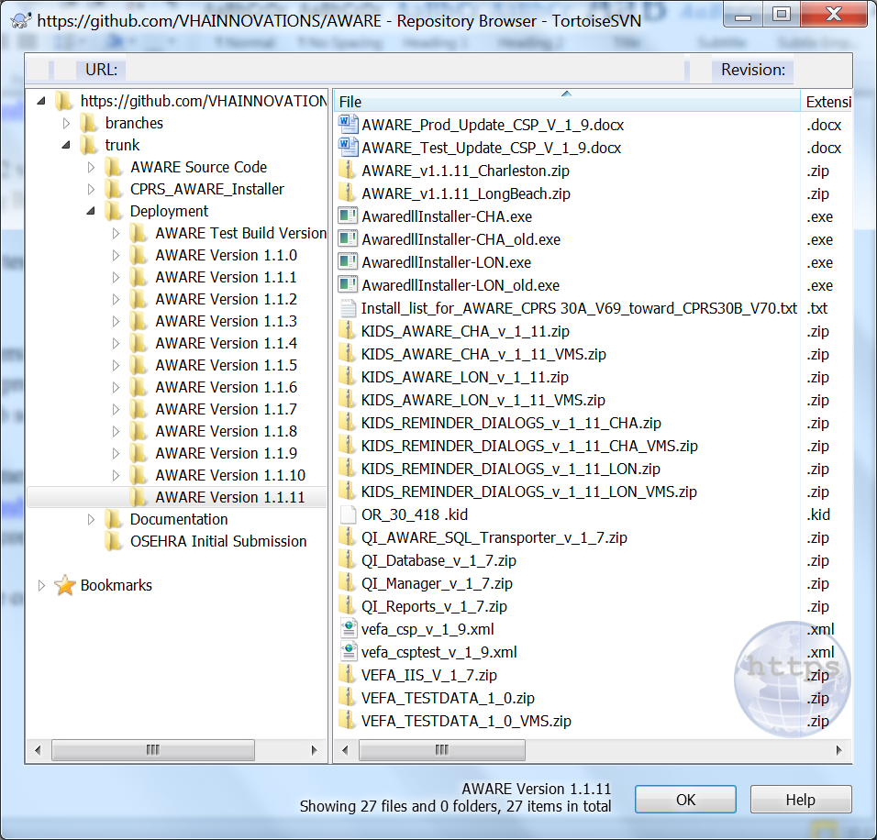

The AWARE_v_1_1.11_Charleston.zip file contains all the components for Charleston. Similarly the AWARE_v_1_1.11_LongBeach.zip file contains all the components for Long Beach.

The individual zip file names for Charleston contain a “CHA”extension, the individual zip files for Long Beach contain a “LON” extension. Also, these installation packagings are available either with or with-out a “VMS” extension for use with either OpenVMS or Linux, respectively.

Continuing with referencing “CHA” or Charleston” the KIDS_REMINDER_DIALOGS_v_1_1_11_CHA*.zip files contains the AWARE software KIDS file and the AWARE Reminder Dialogs provided with the system and some seeding data in another KIDS file for a knowledge database. These are found among the OSEHRA submitted files. Extract the content by unzipping the file.

For information the KIDS_AWARE_CHA_v_1_11*.zip files only contain the AWARE software KIDS file and would be used for any further releases of just the software itself after a first time install.

The equivalent source code equivalents for these zipped components are found at

[https://github.com/VHAINNOVATIONS/AWARE/trunk/AWARE Source Code/KIDS/12_30_2015](https://github.com/VHAINNOVATIONS/AWARE/trunk/AWARE%20Source%20Code/KIDS/12_30_2015)

1. **Installing Mumps AWARE Component**

First install the AWARE software and seen data KIDS files found in the extraction from the appropriate KIDS_REMINDER_DIALOGS_v_1_1_11_CHA*.zip file for your test account. In addition to being found among the OSEHRA initial submitted files, it is also found within the [https://github.com/VHAINNOVATIONS/AWARE/trunk/Deployment/AWARE Version 1.1.11](https://github.com/VHAINNOVATIONS/AWARE/trunk/Deployment/AWARE%20Version%201.1.11) folder. Reminder dialogs will also be in the extractions from this zip file.

Use the **T4_AWARE_InstallGde-KIDS_CSP.docx** file sections 3.1, 3.2, and 3.3 to load and install the 2 KIDS files VEFA_2_0_2CHA.KID and VEFA_1_0_3_KB.KID. In addition to being found among the OSEHRA initial submitted files, this document is also found within the [https://github.com/VHAINNOVATIONS/AWARE/trunk/Documentation/Installation Guide](https://github.com/VHAINNOVATIONS/AWARE/trunk/Documentation/Installation%20Guide) folder

1. **Configuring a Mumps AWARE component**

Test routines and test data then need to be loaded from another zip file,VEFA_TESTDATA_1_0.zip or VEFA_TESTDATA_1_0_VMS.zip file. It is found among the OSEHRA initial submitted files, as well within the [https://github.com/VHAINNOVATIONS/AWARE/trunk/Deployment/AWARE Version 1.1.11](https://github.com/VHAINNOVATIONS/AWARE/trunk/Deployment/AWARE%20Version%201.1.11) folder. Extract its contents.

A multi-build KIDS file should be loaded and installed. This KIDS file is VEFA_TESTDATA_1_0.KID.

With test routines and routine in place, next a configuration/user setup should be for a Mumps only AWARE component testing by following steps in a document **T4_AWARE_Vista_Configuration_Guide-Test.docx** file found with the OSEHRA initial submitted files as well as the within the [https://github.com/VHAINNOVATIONS/AWARE/trunk/Documentation/System Administrator Guide](https://github.com/VHAINNOVATIONS/AWARE/trunk/Documentation/System%20Administrator%20Guide) folder.

In this Guide, do steps 4.1, skip steps 4.2, and 4.3, and then substitute for step 4.4 with the following:

Instead of using a web-based Knowledge Base (KB) Editor program which requires more configuration than is available at this time than just the Mumps only component, use FileMan to edit critical fields in the VEFA Tracked Critical Alert file.

**NOTE:** We recommend that only an OI&T Specialist/Programmer complete this step

Select VA FileMan <TEST ACCOUNT> Option: **enter or Edit File Entries**.

INPUT TO WHAT FILE: **VEFA Tracked Critical Alert** (4 entries)

THEN EDIT WHICH FIELD: ALL// **Reminder Dialog**

THEN EDIT FIELD: **ACTIVE**

THEN EDIT FIELD: **INITIATION DATE**

THEN EDIT FIELD:

Select VEFA Tracked Critical Alert NAME: **`1 [PROSTATE SPECIFIC ANTIGEN]**

Reminder Dialog: //**AVEFA PSA**

ACTIVE: NO// **YES**

INITIATION DATE: **//<- enter current date**

Select VEFA Tracked Critical Alert NAME: **`2 [OCCULT BLOOD]**

Reminder Dialog: //**AVEFA FOBT-FIT**

ACTIVE: NO// **YES**

INITIATION DATE: **////<- enter current date**

Select VEFA Tracked Critical Alert NAME: **`3 CHEST 2 VIEWS FRONT**

Reminder Dialog: //**AVEFA ABNORMAL CXR**

ACTIVE: NO// **YES**

INITIATION DATE: **////<- enter current date**

Select VEFA Tracked Critical Alert NAME: `**4 MAMMOGRAM**

Reminder Dialog: //**AVEFA ABNORMAL MAMMOGRAM**

ACTIVE: NO// **YES**

INITIATION DATE: **////<- enter current date**

Select VEFA Tracked Critical Alert NAME:

Next skips steps 4.5, and 4.6, do only step 4.7.1 in the T4_AWARE_Vista_Configuration_Guide-Test.docx.

Then skip all of section 5.

Four AWARE Reminder Dialogs will also have been installed and loaded upon completion of the configuration steps.

1. **Testing with a Mumps AWARE component**

This testing is a variation of the AWARE Test Case ST-002 in section 6 with the Alert Cache Viewer in the T4_AWARE_TestCases.docx document in the GitHub url folder at [https://github.com/VHAINNOVATIONS/AWARE/trunk/Documentation/Testing Manual](https://github.com/VHAINNOVATIONS/AWARE/trunk/Documentation/Testing%20Manual). Test Case ST-002 is for testing the gathering of essential Alert data into an Alert Cache file. Instead of using a web-based Alert Viewer application to see the captured alerts, FileMan can be used at this time to see an alert in an Alert Cache file.

Do step 6.1.1 in the T4_AWARE_Vista_Configuration_Guide-Test.docx.to only generate a test abnormal imaging alert. Stop at this step.

A captured AWARE alert for an abnormal imaging result should be captured in the VEFA AWARE ALERT CACHE file by the VEFA AWARE ALERT CACHE BUILDERbackground task set-up in section 4.7 of the configuration guide**.**

See the expected Testing Results below in FileMan:

Select OPTION: INQUIRE TO FILE ENTRIES

OUTPUT FROM WHAT FILE: VEFA AWARE ALERT CACHE

Select VEFA AWARE ALERT CACHE ALERTID: `1 OR,418,25;1;3151216.121807 12-16-

2015 @ 12:18:07 CLINCOORDINATOR,TWO - 10000000087

ANOTHER ONE:

STANDARD CAPTIONED OUTPUT? Yes// (Yes)

Include COMPUTED fields: (N/Y/R/B): NO// - No record number (IEN), no Computed

Fields

ALERTID: OR,418,25;1;3151216.121807 DATETIME: DEC 16, 2015@12:18:07

FACILITY NAME: ALBANY VA MEDICAL CENTER

SERVICE: MEDICINE

ORDERING PROVIDER: CLINCOORDINATOR,TWO - 10000000087

ALERT RECIPIENTS: CLINCOORDINATOR,TWO - 10000000087;

PATIENT: SIX,PATIENT

ALERT CATEGORY: Abnl Imaging Reslt, Needs Attn:

ALERT TYPE: CHEST 2 VIEWS UNACKSTATUS: YES

FAT STATUS: NO ORDERS/FOLLOW-UPS MADE

CLINIC: ? PATIENTID: 418

ALERT RESULTOR: PROGRAMMER,ONE ALERT TYPE ORIG STATION: 500

FOLLOWUP>7D: YES ACK>7D: YES

ALERTVALUE: ABNORMAL FOLLOW-UPS: NO

ORIG ALERT TYPE: CHEST 2 VIEWS FRONT

1. **Continued Configuration with CPRS related AWARE Components**

Regular CPRS and AWARE modified CPRS can be used in a Test account

The latest version of AWARE modified CPRS is CPRS30A v69. It requires the patches in file “Install_list_for_AWARE_CPRS 30A_V69_toward_CPRS30B_V70.txt” found in the GitHub url folder <https://github.com/VHAINNOVATIONS/AWARE/trunk/Documentation/InstallationGuide>. However any CPRS can be used in subsequent testing steps with a manual call-up of AWARE Reminder dialogs for doing follow-ups that an AWARE modified CPRS can do thru a customized AWARE CPRS re-direction.

For an AWARE modified CPRS, configuration and user setup is needed. The steps below need to additionally be completed in the **T4_AWARE_Vista_Configuration_Guide-Test.docx** file. This file is found in the [https://github.com/VHAINNOVATIONS/AWARE/trunk/Documentation/System Administrator Guide](https://github.com/VHAINNOVATIONS/AWARE/trunk/Documentation/System%20Administrator%20Guide) folder.

See the table of recommended Tasks for Configuration and AWARE User Assignments in step 3.

Now additionally do steps 4.2 and 4.3, and then substitute for step 4.4 with the following:

Instead of using a web-based Knowledge Base (KB) Editor program which requires more configuration than is available at this time than just use a FileMan to edit critical fields in the VEFA Tracked Critical Alert file.

Note, the TIU Templates defined in step 4.3 can be used for filling in the field value for the TIU TEMPLATEfield**.**

NOTE: We recommend that only an OI&T Specialist/Programmer complete this step

Select VA FileMan <TEST ACCOUNT> Option: **enter or Edit File Entries**.

INPUT TO WHAT FILE: **VEFA Tracked Critical Alert** (4 entries)

EDIT WHICH FIELD: ALL// **TIU TEMPLATE**

THEN EDIT WHICH FIELD: ALL// **Reminder Dialog**

THEN EDIT FIELD: **ACTIVE**

THEN EDIT FIELD: **INITIATION DATE**

THEN EDIT FIELD:

Select VEFA Tracked Critical Alert NAME: **`1 [PROSTATE SPECIFIC ANTIGEN]**

TIU TEMPLATE: // **AWARE ABNORMAL PSA**

Reminder Dialog: //**AVEFA PSA**

ACTIVE: NO// **YES**

INITIATION DATE: **//<- enter current date**

Select VEFA Tracked Critical Alert NAME: **`2 [OCCULT BLOOD]**

TIU TEMPLATE: //**AWARE ABNORMAL FOBT-FIT**

Reminder Dialog: //**AVEFA FOBT-FIT**

ACTIVE: NO// **YES**

INITIATION DATE: **////<- enter current date**

Select VEFA Tracked Critical Alert NAME: **`3 CHEST 2 VIEWS FRONT**

TIU TEMPLATE: //**AWARE ABNORMAL CXR**

Reminder Dialog: //**AVEFA ABNORMAL CXR**

ACTIVE: NO// **YES**

INITIATION DATE: **////<- enter current date**

Select VEFA Tracked Critical Alert NAME: `**4 MAMMOGRAM**

TIU TEMPLATE: //**AWARE ABNORMAL MAMMOGRAM**

Reminder Dialog: //**AVEFA ABNORMAL MAMMOGRAM**

ACTIVE: NO// **YES**

INITIATION DATE: **////<- enter current date**

Select VEFA Tracked Critical Alert NAME:

Now skip for now steps 4.5 and 4.6, and do not repeat 4.7. Then do user setup in steps 5.1, 5.2, 5.3, and skip 5.4, then do all of 5.5.

Section 5.5 calls for an AWARE Installer for an AWARE modified CPRS. This can be found as an AWARE_Installer-CHA.exe file in the url folder [https://github.com/VHAINNOVATIONS/AWARE/trunk/Deployment/AWARE Version 1.1.11](https://github.com/VHAINNOVATIONS/AWARE/trunk/Deployment/AWARE%20Version%201.1.11). This is an installer for CPRS30A v69 which can be installed in the same folder as regular CPRS.

1. **Testing with CPRS related AWARE Components**

This testing is a variation of the AWARE Test Case ST-006 in the section 10.0 of the T4_AWARE_TestCases.docx document in the GitHub url folder at [https://github.com/VHAINNOVATIONS/AWARE/trunk/Documentation/Testing Manual](https://github.com/VHAINNOVATIONS/AWARE/trunk/Documentation/Testing%20Manual). Test Case ST-006 is for testing of the CPRS AWARE Integration.

Below represents the expected test results with either AWARE modified CPRS or other non-modified CPRS in a Test account.

An AWARE modified CPRS the patient closeout prompt will occur when leaving the patient’s chart (patient SIX,PATIENT) to remind the physician he still has not done a follow-up for this abnormal imaging result alert.

However, any other CPRS in a VistA test account can do the same follow-ups with a manually called up AWARE Reminder Dialog to do follow-up actions which will be captured in the VEFA AWARE ALERT CACHE file

See below for an AWARE modified CPRS to prompt with an “Address Now” upon a patient closeout with example patient (SIX,PATIENT in this case) to allow re-directed CPRS to an AWARE Reminder dialog when no follow-up actions have been done. When proper follow-up actions have been done in an AWARE Reminder Dialog, these will be detected by an AWARE dll called by CPRS so as to not prompt again with an “Address Now” upon any subsequent patient closeout. Again these follow-up actions will also be captured in the VEFA AWARE ALERT CACHE file.

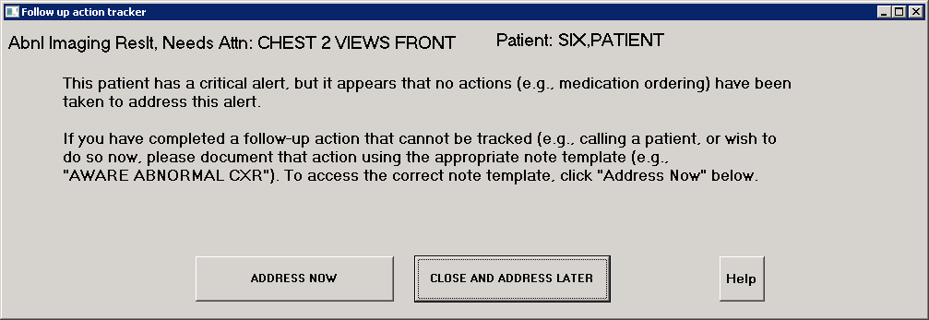

Now with an AWARE modified CPRS with Vista patched to version 69, or any with non-AWARE modified CPRS at any version level in a VistA test account, any follow-up action made thru the re-direction with AWARE modified CPRS, or via normal CPRS with just a manually invoked AWARE Reminder Dialog follow-up actions will be captured by the VEFA AWARE ALERT CACHE BUILDERbackground task. This follow-up action is performed as illustrated below:

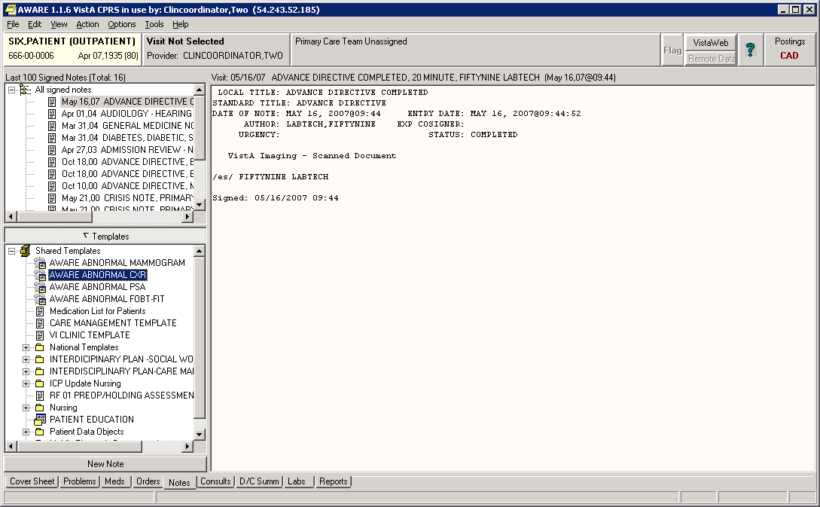

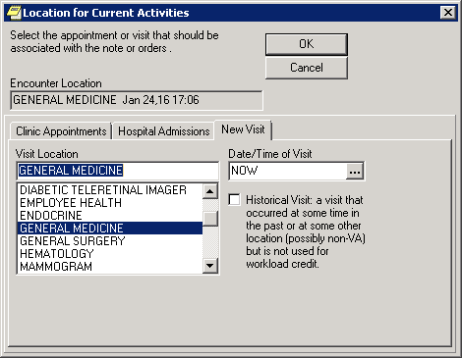

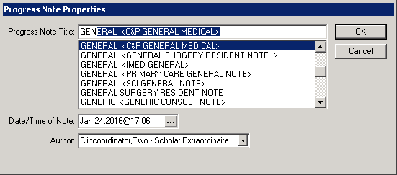

After the AWARE Reminder Dialog comes up as below”

Select Order Chest Biopy order as other follow-ups as below, then click “Finish” and do order(s).

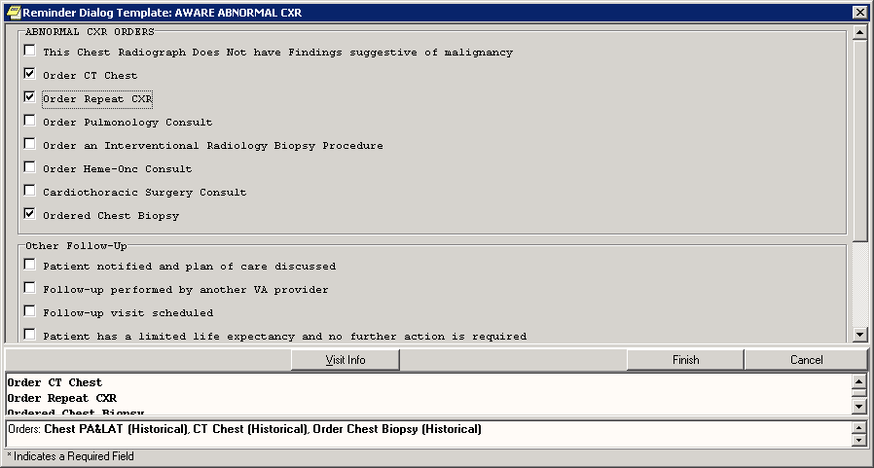

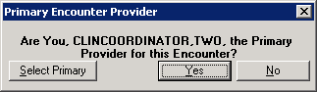

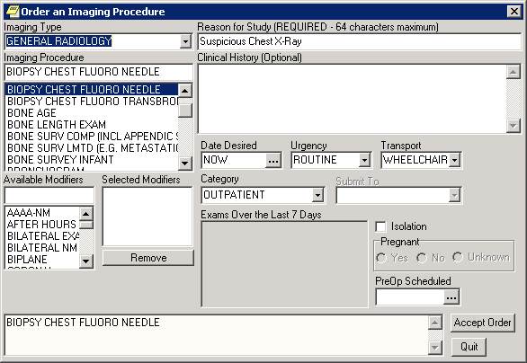

Accept Order and sign.

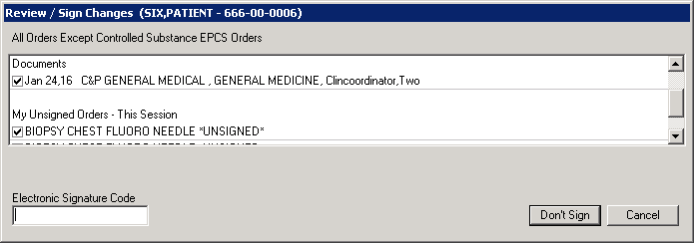

Now no patient closeout prompt occurs as below:

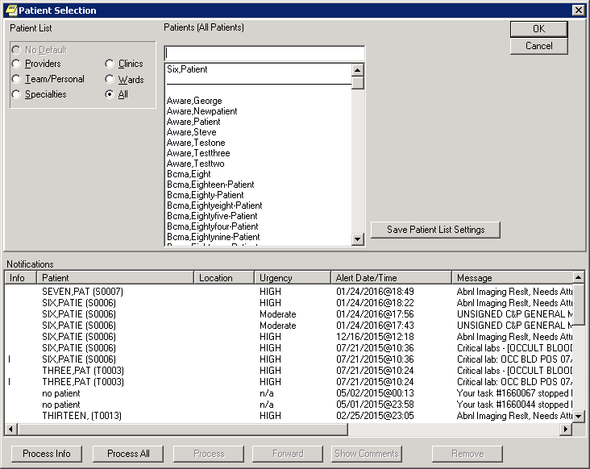

Orders and other health factors as follow-up actions are captured in VEFA AWARE ALERT CACHE file by the by the VEFA AWARE ALERT CACHE BUILDER background task as seen below.

Select VEFA AWARE ALERT CACHE ALERTID: `1 OR,418,25;1;3160124.182213 01-24-

2016 @ 18:22:13 CLINCOORDINATOR,TWO - 10000000087

ANOTHER ONE:

STANDARD CAPTIONED OUTPUT? Yes// (Yes)

Include COMPUTED fields: (N/Y/R/B): NO// - No record number (IEN), no Computed

Fields

ALERTID: OR,418,25;1;3160124.182213 DATETIME: JAN 24, 2016@18:22:13

FACILITY NAME: ALBANY VA MEDICAL CENTER

SERVICE: MEDICINE

ORDERING PROVIDER: CLINCOORDINATOR,TWO - 10000000087

ALERT RECIPIENTS: CLINCOORDINATOR,TWO - 10000000087;

PATIENT: SIX,PATIENT

ALERT CATEGORY: Abnl Imaging Reslt, Needs Attn:

ALERT TYPE: CHEST 2 VIEWS UNACKSTATUS: YES

FAT STATUS: ONE OR MORE ORDERS/FOLLOW-UPS MADE

FOLLOWUP ACTIONS: AW500 CXRY ENTERED NOTE

DATE/TIME: JAN 24, 2016@23:59

FOLLOWUP ACTIONS: AW500 CXRY ORDER CHEST BIOPSY

DATE/TIME: JAN 24, 2016@23:59

FOLLOWUP ACTIONS: AW500 CXRY ORDER CT CHEST

DATE/TIME: JAN 24, 2016@23:59

FOLLOWUP ACTIONS: AW500 CXRY REPEAT CXR

DATE/TIME: JAN 24, 2016@23:59

CLINIC: ? PATIENTID: 418

ALERT RESULTOR: PROGRAMMER,ONE ALERT TYPE ORIG STATION: 500

FOLLOWUP>7D: NO ACK>7D: NO

ALERTVALUE: ABNORMAL FOLLOW-UPS: YES

Enter RETURN to continue or '^' to exit:

ORIG ALERT TYPE: CHEST 2 VIEWS FRONT

See also the **CPRS AWARE Integration User’s guide.docx** in the [https://github.com/VHAINNOVATIONS/AWARE/trunk/Documentation/User Manual](https://github.com/VHAINNOVATIONS/AWARE/trunk/Documentation/User%20Manual) folder.

Testing in general can now proceed with doing steps 6.1.1 and 6.1.2 in the T4_AWARE_Vista_Configuration_Guide-Test.docx. with same test patient as before (in example as SIX,PATIENT) for generating both test lab and abnormal imaging alerts. Exercise the system doing step 6.2. Step 6.3 can be skipped for now with re-factoring as an advanced topic to be used in an eventual Production system.

See also subsequent testing with AWARE modified CPRS in the GitHub url folder [https://github.com/VHAINNOVATIONS/AWARE/trunk/Documentation/Test Manual folder](https://github.com/VHAINNOVATIONS/AWARE/trunk/Documentation/Test%20Manual%20folder)

Note, follow-ups can not only be made in a new visit (date) following alert occurrence, but also with progress notes or addendums at prior visits to count as valid follow-ups because of the nature of the historical event (future times) associated the AWARE Reminder dialog elements. See also other supporting documents for this subject in the folder with GitHub URL [https://github.com/VHAINNOVATIONS/AWARE/trunk/Documentation/Other Supporting Documents](https://github.com/VHAINNOVATIONS/AWARE/trunk/Documentation/Other%20Supporting%20Documents).

1. **Testing with CPRS related AWARE Components in a Production account**

In addition to step 6.3 in the **T4_AWARE_Vista_Configuration_Guide-Test.docx** file, **all the steps** should be done in an analogous **T4_AWARE_Vista_Configuration_Guide-Prod.docx** file when used in a Production account. This includes advanced topics with figuring exact site specific lab test names and radiology procedure names in consultation with Lab and Radiology Chiefs, as well as re-factoring of Reminder dialogs with initially seeded data to use real orderable items, order dialogs, consults, procedures, etc. This Production use document can be found in the [https://github.com/VHAINNOVATIONS/AWARE/trunk/Documentation/System Administrator Guide](https://github.com/VHAINNOVATIONS/AWARE/trunk/Documentation/System%20Administrator%20Guide) folder.

1. **AWARE Documentation Folders**

The AWARE documentation is organized under folder structures shown below under the Documentation folder located at the GitHub url <https://github.com/VHAINNOVATIONS/AWARE/trunk/Documentation>.

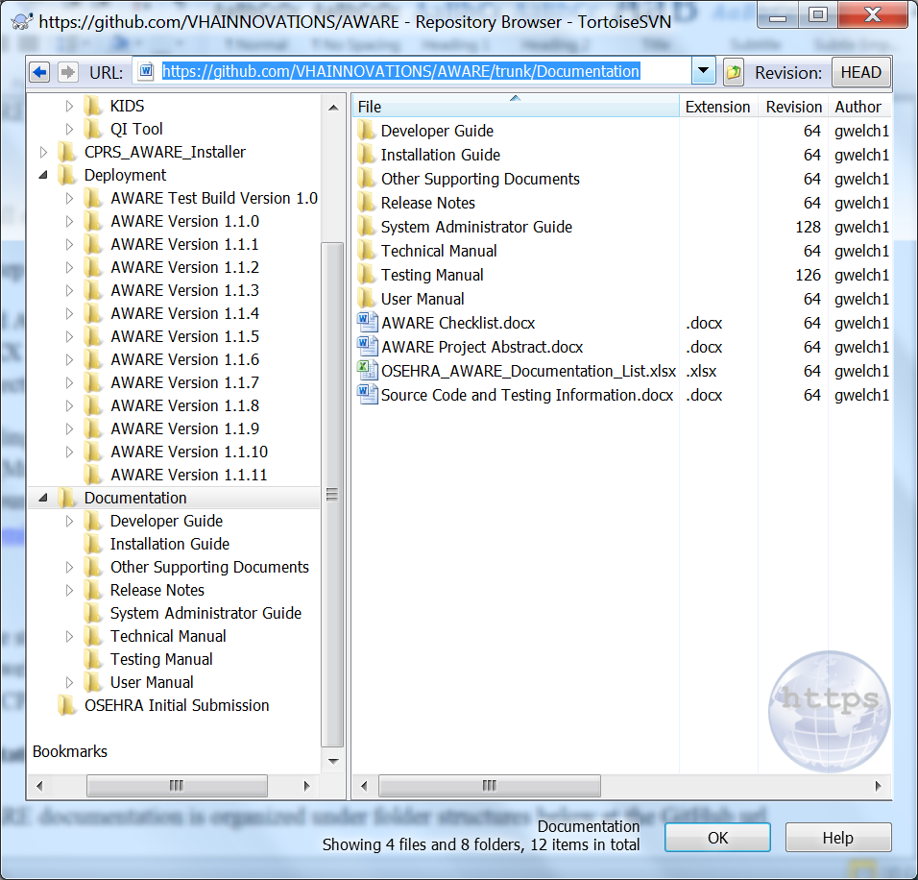

Installation Guides are in the Documentation sub-folder “Installation Guide” as below:

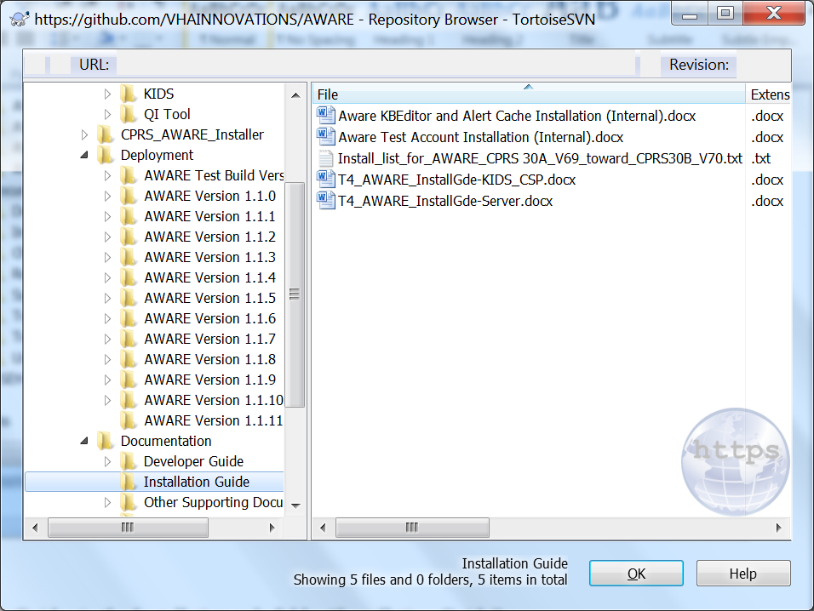

Release notes as Version Description Documents (VDDs) for included changes per version are in the Documentation sub-folder “Release Notes” as below:

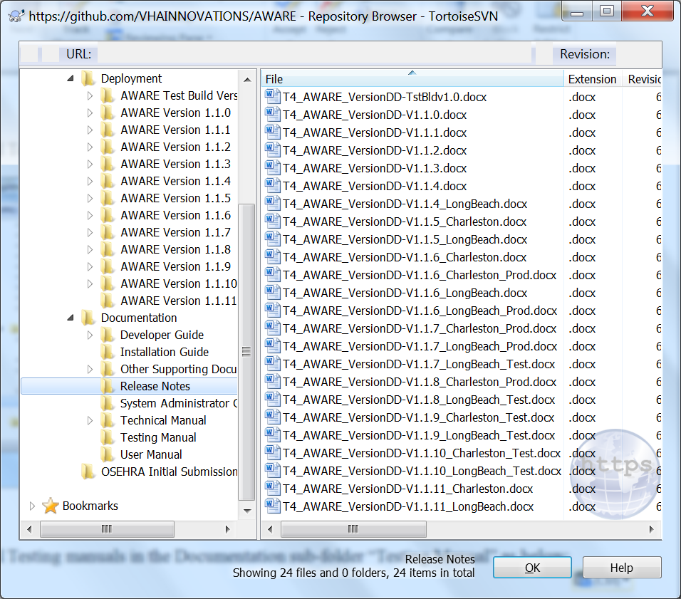

Configuration and System Administration documents in the Documentation sub-folder “System Administrator Guide” folder are shown as below:

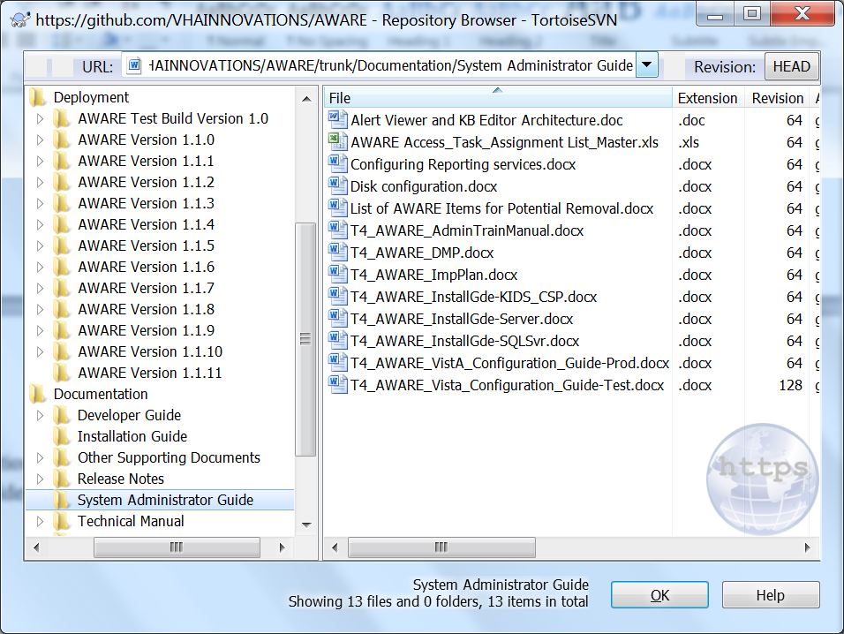

User manuals are in the Documentation sub-folder “User Manual” as below:

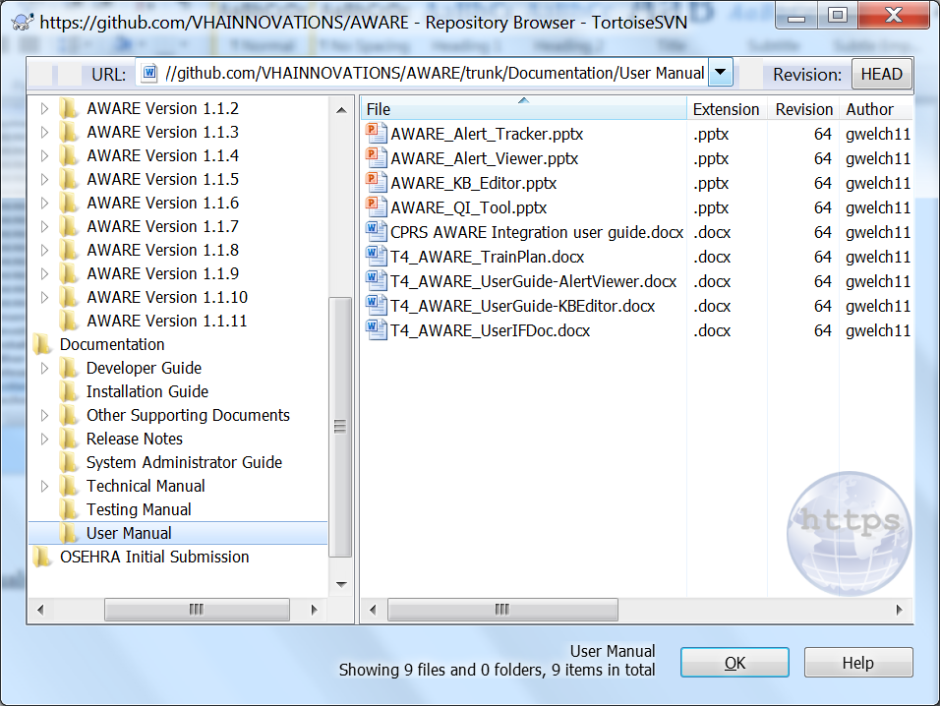

Additional Testing manuals are in the Documentation sub-folder “Testing Manual” as below:

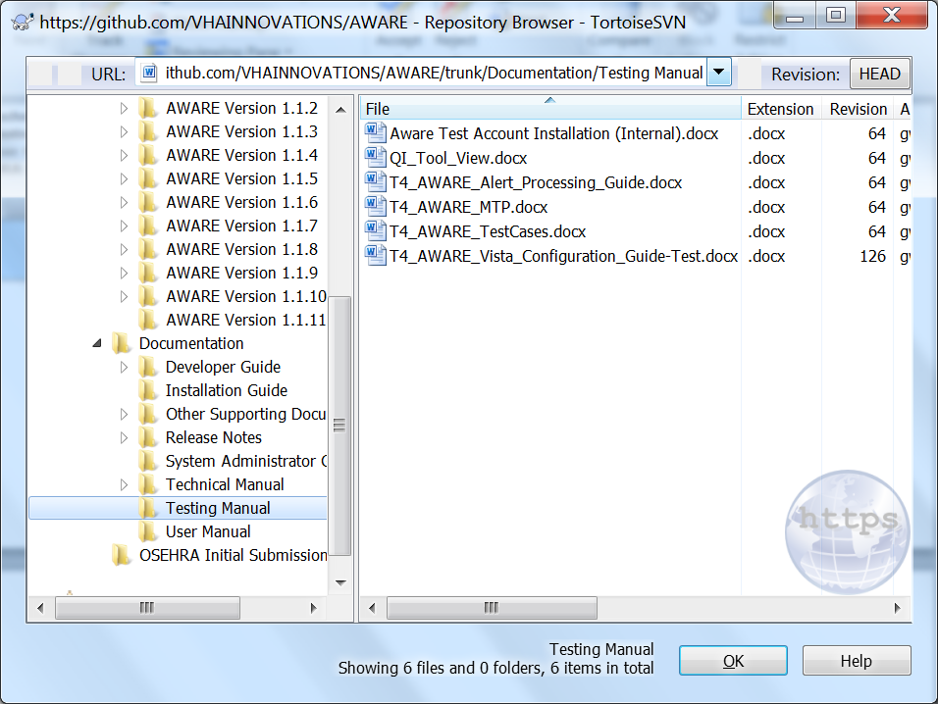

Developer (“Make-File”) manuals in the Documentation sub-folder “Developer Guide” as below:

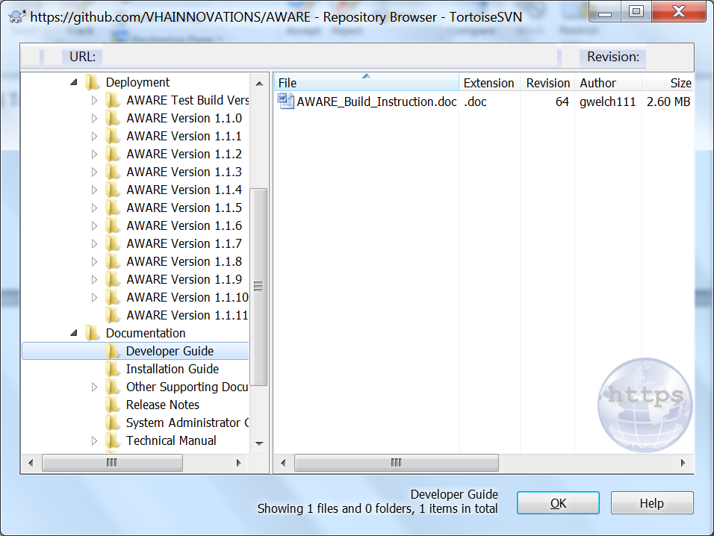

Technical manuals are in the Documentation sub-folder “Technical Manual” as below:

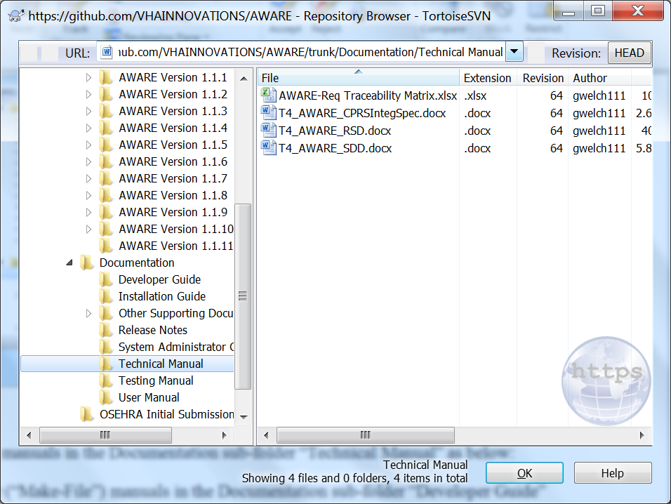

Other supporting documents are in the Documentation sub-folder “Other Supporting Documents” as below:

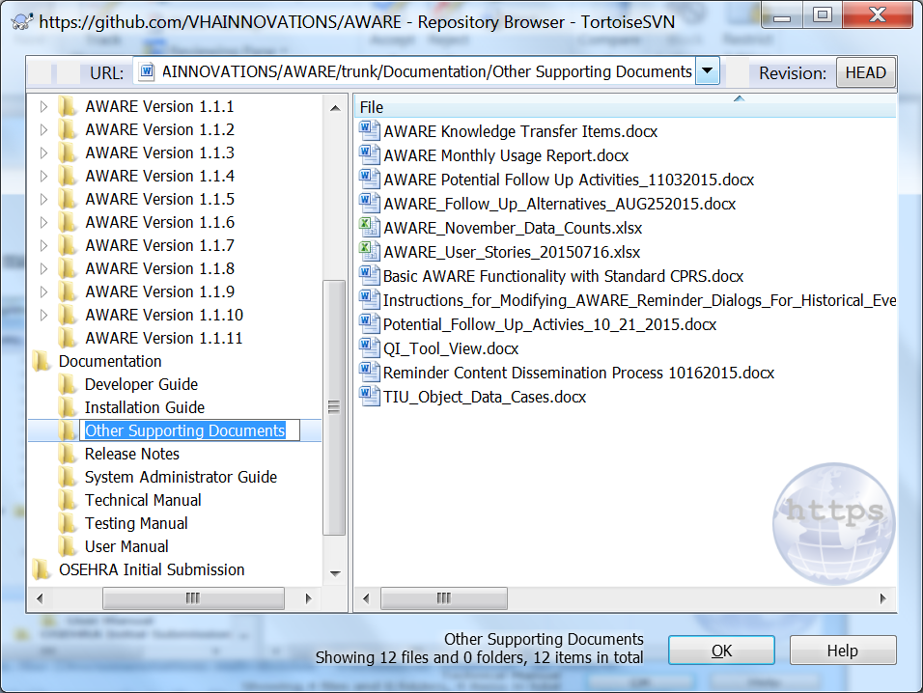

1. **Additional Web-based AWARE Components**

There are additional AWARE components including InterSystems web CSP applications and Windows Server SQL storage and web-based MS SSRS report applications.

The InterSystems CSP web applications include an “Alert Viewer” and an AWARE Knowledge Base (KB) editor. The Alert Viewer shows the AWARE alerts and their any follow-ups over a current 30 day period reflecting status changes day counts of time elapsed from alert occurrence without any follow-ups done.

A Windows Server SQL storage application runs from a Windows server with a so called SQL Transporter task using a C# Remote Procedure call. It collects the data from the VEFA AWARE ALERT CACHE, and purges data in that file after collecting it after a certain period time. All AWARE Alerts are kept for at least 14 days, and only alerts w/o any follow-ups are maintained for another 16 days for a total of 30 days of current alerts in the Alert Cache at any one time.

A Microsoft (MS) SSRS web-based reporting application can run on an applications Windows server machine having MS SQL 2012 engine for storage of historical alerts and their historical follow-up activity.

1. The installation and system configuration of the Alert Viewer ad KB Editor applications starts with establishing a CSP Gateway. The **T4_AWARE_InstallGde-KIDS_CSP.docx** file provides the steps for this installation and configuration also in conjunction with parts of the **T4_AWARE_InstallGde-Server.docx** file. The **T4_AWARE_InstallGde-KIDS_CSP.docx** file was also used with the KIDS file installations previously mentioned in section 2 of guide. It is located in a folder with url [https://github.com/VHAINNOVATIONS/AWARE/trunk/Documentation/Installation Guide](https://github.com/VHAINNOVATIONS/AWARE/trunk/Documentation/Installation%20Guide). There is some additional documentation including system administration documentation for this as well. This latter documentation is found in both the folder with GitHub url [https://github.com/VHAINNOVATIONS/AWARE/trunk/Documentation/Installation Guide](https://github.com/VHAINNOVATIONS/AWARE/trunk/Documentation/Installation%20Guide) and folder with GitHub url <https://github.com/VHAINNOVATIONS/AWARE/trunk/Documentation/SystemAdministratorGuide>.

Deployment information is found in a folder with url [https://github.com/VHAINNOVATIONS/AWARE/trunk/Deployment/AWAREVersion 1.1.11](https://github.com/VHAINNOVATIONS/AWARE/trunk/Deployment/AWAREVersion%201.1.11) as shown below with files having “CSP extensions:

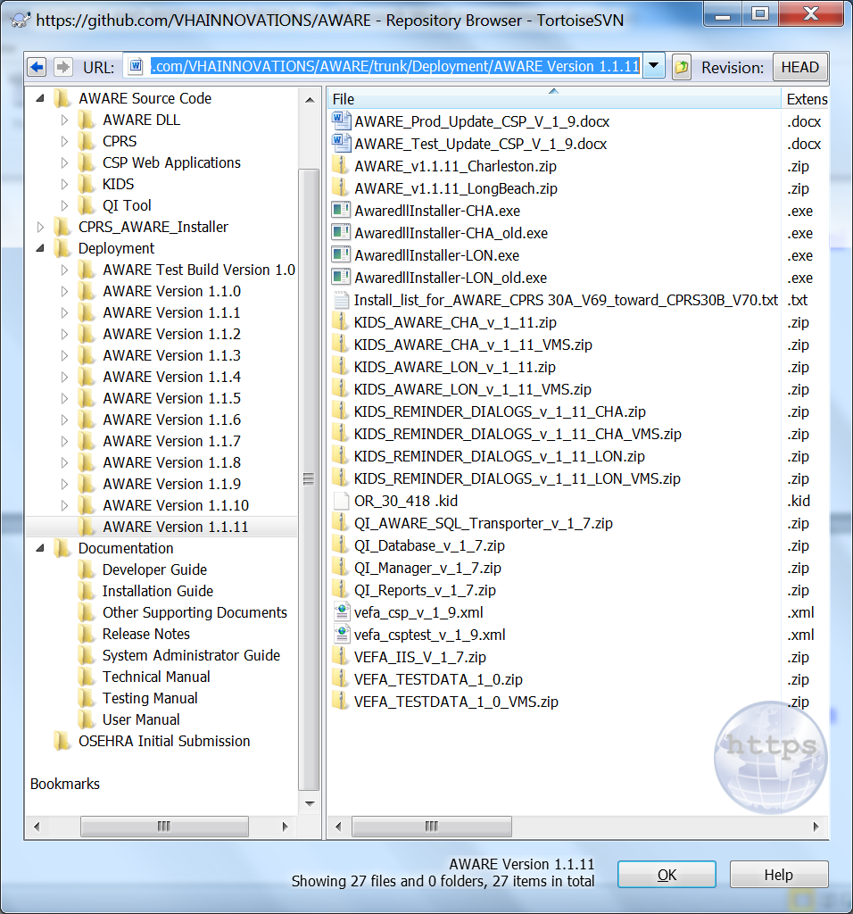

User Guides for the “Alert Viewer” and “KB Editor” are in the folder with GitHub url [https://github.com/VHAINNOVATIONS/AWARE/trunk/Documentation/User Manual](https://github.com/VHAINNOVATIONS/AWARE/trunk/Documentation/User%20Manual). These are **T4_AWARE_UserGuide-AlertViewer.docx** and **T4_AWARE_UserGuide-KBEditor.docx** files, respectively.

1. A “Quality Indicator (QI) Tool application is another AWARE component for deployment. This application includes a SQL Transporter application as well as managed a web-based MS SSRS reporting tool with security access for viewing these reports. The installation and configuration documentation for these applications are in the folder with GitHub url [https://github.com/VHAINNOVATIONS/AWARE/trunk/Documentation/Installation Guide](https://github.com/VHAINNOVATIONS/AWARE/trunk/Documentation/Installation%20Guide). The file in particular is the **T4_AWARE_InstallGde-Server.docx** file.

The deployment files for the QI Tool are in the folder with url [https://github.com/VHAINNOVATIONS/AWARE/trunk/Deployment/AWAREVersion 1.1.11.These](https://github.com/VHAINNOVATIONS/AWARE/trunk/Deployment/AWAREVersion%201.1.11.These) files include QI_AWARE_SQL_Transporter_v_1_7.zip, QI_Database_v_1_7.zip, QI_Manager_v_1_7.zip, QI_Reports_v_1_7.zip, and VEFA_IIS_V_1_7.zip.

For both sub-section a. and b. there are PowerPoint training files in the folder with GitHub url [https://github.com/VHAINNOVATIONS/AWARE/trunk/Deployment/AWARE Version 1.1.1](https://github.com/VHAINNOVATIONS/AWARE/trunk/Deployment/AWARE%20Version%201.1.1)1.

1. **Additional AWARE References**
2. There are technical documents in a folder at GitHub url [https://github.com/VHAINNOVATIONS/AWARE/trunk/Documentation/Technical Manual](https://github.com/VHAINNOVATIONS/AWARE/trunk/Documentation/Technical%20%20Manual). These include an **AWARE-Req Traceability Matrix.xlsx**, **T4_AWARE_RSD.docx**, a **T4_AWARE_CPRSIntegSpec.docx**, and a **T4_AWARE_SDD.docx** file.
3. There is a Developer Folder with a Build File document with instructions for use with Make Files to re-construct the deployments from original source code and elements. This build file is in the folder with GitHub url <https://github.com/VHAINNOVATIONS/AWARE/trunk/Documentation/DeveloperGuide>. The file is **AWARE_Build_Instruction.doc**.
4. Release Notes are in Version Description Documents (VDDs) in a folder with GitHub url [https://github.com/VHAINNOVATIONS/AWARE/trunk/Documentation/Release Notes](https://github.com/VHAINNOVATIONS/AWARE/trunk/Documentation/Release%20Notes). Each file has a version number notating changes, updates, enhancements at that version. The latest version is 1.1.11 which is either for the **T4_AWARE_VersionDD-V1.1.11_Charleston.docx** or **T4_AWARE_VersionDD-V1.1.11_LongBeach.docx** file**.**
5. There are Deployment folders for software versions which match the Release Notes folder for Version Description Documents (VDDs). There is latest folder for deployment at GitHub url [https://github.com/VHAINNOVATIONS/AWARE/trunk/Deployment/AWARE Version 1.1.11](https://github.com/VHAINNOVATIONS/AWARE/trunk/Deployment/AWARE%20%20Version%201.1.11) matching **T4_AWARE_VersionDD-V1.1.11_Charleston.docx** or **T4_AWARE_VersionDD-V1.1.11_LongBeach.docx** file.
6. There is other supporting information in the folder with GitHub url [https://github.com/VHAINNOVATIONS/AWARE/trunk/Documentation/Other Supporting Documents](https://github.com/VHAINNOVATIONS/AWARE/trunk/Documentation/Other%20Supporting%20Documents). These files are shown below:

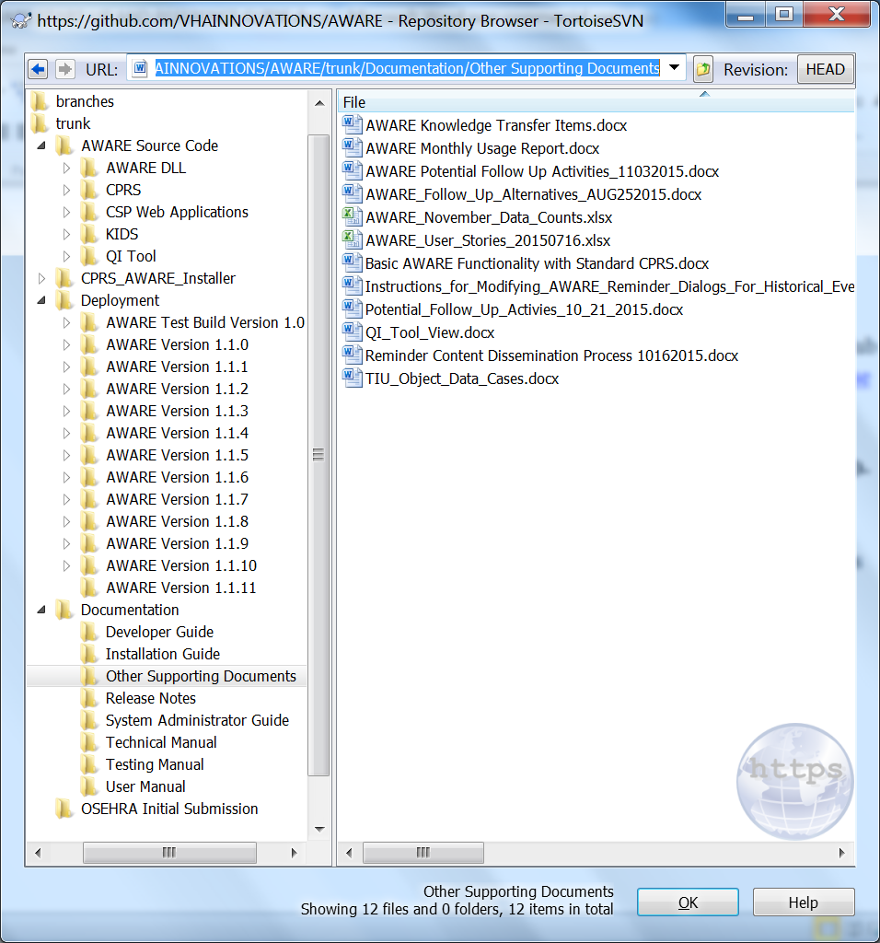

1. Source code is found in the folder with GitBub url [https://github.com/VHAINNOVATIONS/AWARE/trunk/AWARE Source Code](https://github.com/VHAINNOVATIONS/AWARE/trunk/AWARE%20Source%20Code)

There are sub-folders for the AWARE dll code written in Delphi (sub-folder AWARE DLL), the AWARE modified CPRS code written in Delphi with latest as CPRS30A V69 ( sub-folder CPRS), the source for the CSP web applications including .CSP , .CLS, html, and java code ( sub-folder CSP Web Applications), the KIDS builds and Reminder Dialogs, etc. with additional sub folders for different versions of the KIDs builds at different release dates matching the release notes and deployments folders (sub-folder KIDS), and the QI tool application source code including C# code SQL, MS SSRS, and web service code (QI Tool sub-folder).

1. The AWARE Installer source for installing an AWARE modified CPRS with its AWARE dll is in a folder with GitHub url <https://github.com/VHAINNOVATIONS/AWARE/trunk/CPRS_AWARE_Installer>.

The latest installer is for the AWARE modified CPRS30 v69 version.

1. There are additional files in the folder at GitHub url <https://github.com/VHAINNOVATIONS/AWARE/trunk/Documentation>. These are shown below in the root of the Documentation folder.

